Synchronization

Why do we need Synchronization ?
Synchronization of different media streams, e.g. in videoconferencing: audio and video are transmitted as two independent streams. So, synchronization has to take place when streams are played. Furthermore distributed operations must be coordinated for in-time data delivery and buffer management. Most media synchronization schemes demand for knowledge about temporal relations between source and sink(s) . So accurate global time scale is required.

Example: Audio/Video presentation with multiple sources
• Presentation at sink must start at T_{C}
• Sources A and B must start at T_{C} - O_{AC} – D_{AC} and T_{C} - O_{BC} - D_{BC}
• Problem: O_{AC}, O_{BC}, D_{AC}, D_{BC} unknown

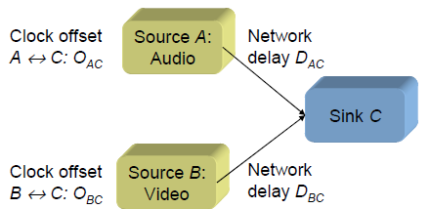

Problem of synchronization
• Universal Coordinated Time (UCT): International time and frequency standard, based on synchronized Caesium clocks (accuracy about 10-12 sec)
• Investigation of 20,000 clocks of Internet hosts: 50% show offset > 2 minutes (with respect to UCT), 10 % show offset > 4 hours, some several weeks!
Reasons
• Clock adjustment usually via wrist watch of operator
• Differences in the oscillator frequencies (clock drift)
→ clocks tend to wander from the exact time
• Drift in parts per million (ppm) sometimes as high as a few hundred ppm (or some seconds per day)
• Further problems: Clock resolution (as bad as 10 ms), non real-time operating systems (e.g., UNIX)

Definition
Synchronization is refers to temporal relations between media objects in the multimedia systems
- Media objects can be
  - Time dependent
  - Time independent

Synchronization Issues
- Handling inherent dependencies of the media objects involved
- Dependencies include content, spatial & temporal relations between media objects.

Content relations
  - Two graphics depend on same data (in spreadsheet), give different statistical representations
Temporal relations
  - Temporal dependencies between media objects
Spatial Relations
  - Known as layout relationships
  - Layout frames used in desktop publishing

Different Types of Synchronization

1. Intra & Inter-Object Synchronization

- Intra-object synchronization
  - Time relations between various presentation units of one time-dependent media object
  - Time relations between single frames of a vide sequence
    - 25 frames /sec 40 ms per frame
Fig:Video Sequence showing bouncing ball (Intra-object synchronization)
- Inter-Object Synchronization
  - Refers to synchronization between media objects
Fig:Temporal relationships between media objects
What is Time dependent presentation units ?
  - Consisting of sequence of information units, known as Logical Data Units (LDU)
  - Various Granularity levels
    - Samples Notes Movements Symphony
    - Frames scenes video
  - Selection of LDU’s dependent on application
    - For a play application, symphony / movements can form LDU
  - Granularity implies a hierarchical decomposition of media objects
- For video, frames serves as LDU
- For Audio, group of samples (usually 512) serve as LDU
- For user generated media objects, duration of LDU’s can be selected by user
- When LDU’s vary in duration, streams become complex
  - Recording users interactions with computer
  - LDU’s may be video between user interaction
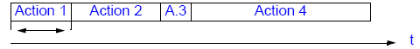
Types of LDU
- Open LDU
  - The LDU duration is not known in advance, because the duration of interaction is not known in advance
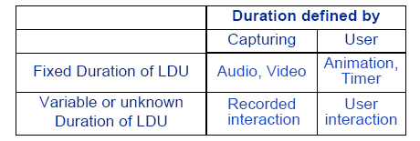
Table: Types of LDU’s
- Classification of LDU –overview
  - Open vs. closed
  - Fixed vs. variable duration
  - User defined vs. capturing related
  - Physical vs. Blocked

2. Live & Synthetic Synchronization

- Live Synchronization
  - At presentation, reproduce the temporal relations as they existed in the capturing process
  - Ex: Video conferencing application
- Synthetic Synchronization
  - Temporal relations are artificially specified
  - Ex: Online virtual tours
    - Media objects created independently are synchronized
    - A model for specification & manipulation of temporal synchronization conditions & operations is necessary
  - Specification Phase
    - Define temporal relations between media objects
  - Presentation Phase
    - Run-time system presents data in a synchronized mode
- In Live synchronization,
  - Synchronization specification is implicitly specified during data capturing
  - User interactions are possible only at capturing

Synchronization Reference Model

- A reference model is needed
  - To understand various requirements for multimedia synchronization
  - Identify & Structure run-time mechanisms that support execution of synchronization
  - Identify interfaces between runtime mechanisms
  - Compare system solutions for multimedia synchronization systems
- Existing classification approaches are :
  - Physical Level, System Level & human level [Little &Ghafoor-’ 90]
  - Intra-Stream & Inter-Stream [Little &Ghafoor-’ 90]
  - Live-Stream & Synthetic Stream [Little &Ghafoor-’ 90]
  - Mapping between synchronized multimedia object to uninterpretted byte stream [Gibbs, Breitender, Tschichritzis-’ 93]
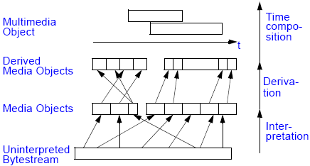
Fig:Mapping
- Layered model (A Referenced Model)
  - Each layer implements synchronization mechanisms
  - Each layer is provided with appropriate interfaces
  - Each interface defines services, a means for the user to define his/her requirements
  - Each interface can be used by applications or next higher layer
  - Higher layers offers higher Programming & QoS Abstractions
Fig:Four layer reference model
Media Layer
- An application operates on a single continuous media stream, which is treated as a sequence of LDU’s
- Abstraction offered at this layer is device independent interface, with operations like
  - read(devicehandle, LDU), write(devicehandle, LDU)
- Application is responsible for intra-stream synchronization by using flow-control mechanisms between a producing & consuming device
- Handling is difficult with multiple streams, distributed environment
- Inter-stream synchronization like, Lip-sync would be provided by interleaving audio & visual information in a LDU
- Media layer implementations can be
  - Simple
  - Interleaved
Stream Layer
- Operates on continuous media streams, as well as groups of media streams
  - In a group, all streams are presented in parallel
- Abstraction offered is the notion of streams with timing parameters concerning QoS for intra-stream & inter-stream synchronization between streams of a group
- Individual LDU’s are not visible here
- Streams are executed in RTE by applications invokes stream layer services in NRTE
- Typical NRTE functions to manage streams/ groups are
  - Start(stream)
  - Stop(stream)
  - Create_group(stream)
  - Start(group)
  - Stop(group)
- The interaction of time-independent media or user interactions with continuous streams is performed by the attachment of events
  - setcuepoint(stream/group, at, event)
- Application using stream layer is responsible for starting, stopping & grouping the streams with the definition of required QoS
Object Layer
- Operates on all types of media & hides the difference between discrete & continuous media
- The abstraction offered to the application is that of a complete, synchronized presentation
  - Takes synchronization specification as input & is responsible for the correct schedule of the overall presentation
- Functions located at this layers are
  - Compute & execute complete presentation schedules
  - Initiate preparation actions, necessary for achieving correctly synchronized presentations
  - For inter-stream & intra-stream synchronization, it uses stream layer
Specification Layer
- Open layer
  - Does not contain an explicit interfaces
  - Contain applications & tools that allow to create synchronization specifications
  - Contain tools for converting specifications into object layer formats
  - Maps QoS requirements of user to object layer requirement

What are the Presentation Requirements ?

- It's Difficult to provide an objective measurement at users viewpoint on synchronization
  - Human perception varies from person to person
- Presentation requirements consists
  - Intra-object synchronization
  - Inter-object synchronization
- Blocking & Gap Problems !
  - Restricted blocking
Examples of Synchronization

Lip Synchronization
- Temporal relationship between audio & video for the case of humans speaking
  - Time difference between related audio & video LDU’s known as skew

- Present the recorded presentation with artificially included skews, in steps of 40ms

Pointer Synchronization
Skew Values
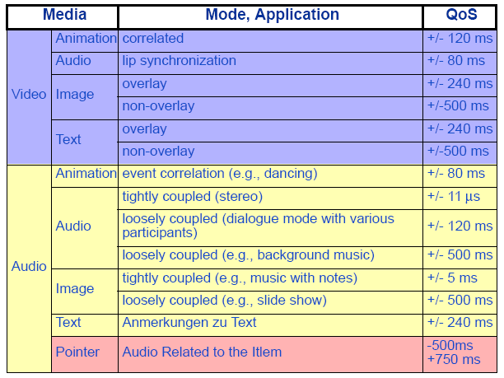

Synchronization Specification

- Synchronization specification of multimedia object describes all temporal dependencies of the included objects in the multimedia project
- Synchronization specification comprised of
  - Intra-object synchronization specifications
  - QoS descriptions for intra-object synchronization
  - Inter-object synchronization specifications
  - QoS descriptions for inter-object synchronization
- Requirements of a specification method are
  - Shall support object consistency & maintenance of synchronization specification
  - Media objects should be kept as a single logical unit in the specification
  - All types of synchronization relations may be describable
  - Support of integration of time independent & dependent media objects
  - QoS requirements must be describable
  - Support of hierarchical levels of synchronization
Basic hierarchical specification
- Two main synchronization operations
  - Serial synchronization of actions
  - Parallel synchronization of operations
- Multimedia objects are regarded as a tree, nodes representing serial / parallel operations
- An action can be
  - Atomic
    - Handles presentation of a single media object, user input or delay
  - Compound
    - Combination of synchronization operators & atomic actions

- Not all relations are describable
- No adequate abstractions for media object contents

How to Achieve Synchronization ?

Based on Global Timer
- All single medium objects are attached to time axis that represents an abstraction of real time
- A world time is maintained
  - Each object maps it to it’s local time
- Provides better abstractions from the internal structure of single medium objects & nested multimedia objects
  - Needs no knowledge about the frames to synchronize it with corresponding audio
Based on Virtual Axis
- Generalization of time axis approach
  - Possible to specify coordinate systems with user define units
  - Synchronization specification is based on these axes
Based on Reference points
- Time dependent single medium objects are regarded as sequences of closed LDUs
  - Start & stop of the presentation of media objects, start time of all sub units of the presentation are called reference points
- Synchronization is defined by connecting reference points
  - Set of connected reference points are called synchronization point
Event Based
- Presentation actions are initiated by synchronization events
  - Actions
    - Start a presentation
    - Stop a presentation
    - Prepare a presentation
  - Events
    - External
      - Generated by a timer
    - Internal
      - Generated by a time-dependent media object that reaches a specific LDU
Interval Based
- Enhanced interval based method used interval relations
  - 10 operators
- A slide show with slides Slide_{i}(i from 1 to n) & an audio object Audio can be specified by this model by

Slide ₁ cobegin(0) Audio
Slide _{i} before(0) Slide _{i+1} (for i from 1 to n-1)
This model does not handle skew specifications !!!

